**REPORT FOR FAKE NEWS DETECTION**

as a project work for the course

**ADVANCE MACHINE LEARNING(INT 248)**

**Name :** Dinil Pradeep

**Registration Number :** 11804970

**Name :** Mohsin Bashir Lone

**Registration Number :** 11807947

**Name :** Sarthak Panwar

**Registration Number :** 11808233

**Program :** B. Tech CSE

**School :** School of Computer Science and Engineering.

**Date of Submission :**  20 th November, 2021



**Lovely Professional University Jalandhar, Punjab, India.**

**ABSTRACT:-**

Fake News has become one of the major problem in the existing society. Fake News has high potential to change opinions, facts and can be the most dangerous weapon in influencing society. The proposed project uses NLP techniques for detecting the 'fake news', that is, misleading news stories which come from non-reputable sources. By building a model based on a K-Means clustering algorithm, the fake news can be detected . The data science community has responded by taking actions against the problem. It is impossible to determine a news as real or fake accurately. So the proposed project uses the datasets that are trained using count vectorizer method for the detection of fake news and its accuracy will be tested using machine learning algorithms

**ACKNOWLEDGEMENT:-**

We would like to thank our faculty - Dr. Dhanpratap Singh

for his advice and inputs on this project. Many thanks to my friends and seniors as well, who spent countless hours to listen and providing feedbacks.

.

**TABLE OF CONTENTS**

# **Introductions**

1. Machine learning and NLP
2. Motivation of work

# **Methodology**

1. Proposed System
2. System Architecture

# **Concept**

1. Classification
2. KNN classifier
3. Evaluation Measures

# **Screenshots**

# **Conclusions and Future reference**

**INTRODUCTION**

**MACHINE LEARNING AND NLP:**

**MACHINE LEARNING**

Machine learning (ML) is the scientific study of algorithms and statistical models that computer systems use to perform a specific task without using explicit instructions, relying on patterns and inference instead. It is seen as a subset of artificial intelligence. Machine learning algorithms build a mathematical model based on sample data, known as "training data", in order to make predictions or decisions without being explicitly programmed to perform the task. Machine learning is closely related to computational statistics, which focuses on making predictions using computers. The study of mathematical optimization delivers methods, theory and application domains to the field of machine learning. "A computer program is said to learn from experience E with respect to some class of tasks T and performance measure P if its performance at tasks in T, as measured by P, improves with experience E.” This is Alan Turing’s definition of machine learning. Deep learning is a class of machine learning algorithms that utilizes a hierarchical level of artificial neural networks to carry out the process of machine learning. The artificial neural networks are built like the human brain, with neuron nodes connected together like a web. While traditional programs build analysis with data in a linear way, the hierarchical function of deep learning systems enables machines to process data with a nonlinear approach. The word "deep" in "deep learning" refers to the number of layers through which the data is transformed. More precisely, deep learning systems have a substantial credit assignment path (CAP) depth. The CAP is the chain of transformations from input to output. CAPs describe potentially causal connections between input and output. For a feedforward neural network, the depth of the CAPs is that of the network and is the number of hidden layers plus one (as the output layer is also parameterized). For recurrent neural networks, in which a signal may propagate through a layer more than once, the CAP depth is potentially unlimited. Deep learning architectures such as deep neural networks, deep belief networks, recurrent neural networks and convolutional neural networks have been applied to fields including computer vision, speech recognition, natural language processing, audio recognition, social network filtering, machine translation, bioinformatics, drug design, medical image analysis, material inspection and board game programs, where they have produced results comparable to and in some cases superior to human experts.

**NATURAL LANGUAGE PROCESSING**

NLP is an area of computer science and artificial intelligence concerned with the interactions between computers and human (natural) languages, in particular how to program computers to fruitfully process large amounts of natural language data. Natural language processing (NLP) is a subfield of linguistics, computer science, information engineering, and artificial intelligence concerned with the interactions between computers and human (natural) languages, in particular how to program computers to process and analyse large amounts of natural language data.

**MOTIVATION OF WORK**

The rise of fake news during the 2016 U.S. Presidential Election highlighted not only the dangers of the effects of fake news but also the challenges presented when attempting to separate fake news from real news. Fake news may be a relatively new term but it is not necessarily a new phenomenon. Fake news has technically been around at least since the appearance and popularity of one-sided, partisan newspapers in the 19th century. However, advances in technology and the spread of news through different types of media have increased the spread of fake news today. As such, the effects of fake news have increased exponentially in the recent past and something must be done to prevent this from continuing in the future. I have identified the three most prevalent motivations for writing fake news and chosen only one as the target for this project as a means to narrow the search in a meaningful way. The first motivation for writing fake news, which dates back to the 19th century one-sided party newspapers, is to influence public opinion. The second, which requires more recent advances in technology, is the use of fake headlines as clickbait to raise money. As such, this paper will focus primarily on fake news as defined by politifact.com, “fabricated content that intentionally masquerades as news coverage of actual events.” This definition excludes satire, which is intended to be humorous 8 and not deceptive to readers. Most satirical articles come from sources. Satire can already be classified, by machine learning techniques Therefore, our goal is to move beyond these achievements and use machine learning to classify, at least as well as humans, more difficult discrepancies between real and fake news. The dangerous effects of fake news, as previously defined, are made clear by events in which a man attacked a pizzeria due to a widespread fake news article. This story along with analysis provide evidence that humans are not very good at detecting fake news, possibly not better than chance . As such, the question remains whether or not machines can do a better job. There are two methods by which machines could attempt to solve the fake news problem better than humans. The first is that machines are better at detecting and keeping track of statistics than humans, for example it is easier for a machine to detect that the majority of verbs used are “suggests” and “implies” versus, “states” and “proves.” Additionally, machines may be more efficient in surveying a knowledge base to find all relevant articles and answering based on those many different sources. Either of these methods could prove useful in detecting fake news, but we decided to focus on how a machine can solve the fake news problem using supervised learning that extracts features of the language and content only within the source in question, without utilizing any fact checker or knowledge base. For many fake news detection techniques, a “fake” article published by a trustworthy author through a trustworthy source would not be caught. This approach would combat those “false negative” classifications of fake news. In essence, the task would be equivalent to what a human faces when reading a hard copy of a newspaper article, without internet access or outside knowledge of the subject (versus reading something online where he can simply look up relevant sources). The machine, like the human in the coffee shop, will have only access to the words in the article and must use strategies that do not rely on blacklists of authors and sources. The current project involves utilizing machine learning and natural language processing techniques to create a model that can expose documents that are, with 9 high probability, fake news articles. Many of the current automated approaches to this problem are centered around a “blacklist” of authors and sources that are known producers of fake news. But, what about when the author is unknown or when fake news is published through a generally reliable source? In these cases it is necessary to rely simply on the content of the news article to make a decision on whether or not it is fake. By collecting examples of both real and fake news and training a model, it should be possible to classify fake news articles with a certain degree of accuracy. The goal of this project is to find the effectiveness and limitations of language-based techniques for detection of fake news through the use of machine learning algorithms including but not limited to convolutional neural networks and recurrent neural networks. The outcome of this project should determine how much can be achieved in this task by analyzing patterns contained in the text and blind to outside information about the world.

**METHODOLOGY**

**PROPOSED SYSTEM**

The proposed system when subjected to a scenario of a set of news articles , the new articles are categorized as true or fake by the existing data available . This prediction is done by using the relationship between the words used in the article with one another. The proposed system contains a Word2Vec model for finding the relationship between the words and with the obtained information of the existing relations , the new articles are categorized into fake and real news.

**SYSTEM ARCHITECTURE**

Input is collected from various sources such as newspapers , social media and stored in datasets. System will take input from datasets. The datasets undergo preprocessing and the unnecessary information is removed from it and the data types of the columns are changed if required. Jupyter notebook and python libraries are used in the above step. Count vectorizer technique is used in the initial step. For fake news detection , we have to train the system using dataset. Before entering to the detection of fake news , entire dataset is divide into two datasets . 80% is used for training and 20% is used for testing. During training , Classification algorithm is used to train the model using the train dataset. In testing , the test dataset is given as input and the output is predicted.After the testing time , The predicted output and the actual output are compared using confusion matrix obtained .The confusion matrix gives the information regarding the number of correct and wrong predictions in the case of real and fake news.The accuracy is calculated by the equation No Of Correct Predictions/Total Test Dataset Input Size

**CONCEPT**

**CLASSIFICATION:**

#### Text classification

Text clarification is the process of categorizing the text into a group of words. By using NLP, text classification can automatically analyze text and then assign a set of predefined tags or categories based on its context. NLP is used for sentiment analysis, topic detection, and language detection. There is mainly three text classification approach-

* Rule-based System,
* Machine System
* Hybrid System.

In the rule-based approach, texts are separated into an organized group using a set of handicraft linguistic rules. Those handicraft linguistic rules contain users to define a list of words that are characterized by groups. For example, words like Donald Trump and Boris Johnson would be categorized into politics. People like LeBron James and Ronaldo would be categorized into sports.

Machine-based classifier learns to make a classification based on past observation from the data sets. User data is prelabeled as tarin and test data. It collects the classification strategy from the previous inputs and learns continuously. Machine-based classifier usage a bag of a word for feature extension.

**KNN CLASSIFIER:**

K-Nearest Neighbors (KNN) is one of the simplest algorithms used in [Machine Learning for regression](https://quantra.quantinsti.com/course/trading-with-machine-learning-regression) and classification problem. KNN algorithms use data and classify new data points based on similarity measures (e.g. distance function).

Classification is done by a majority vote to its neighbors. The data is assigned to the class which has the nearest neighbors. As you increase the number of nearest neighbors, the value of k, accuracy might increase.

**EVALUATION MEASURES**:

Whenever we build Machine Learning models, we need some form of metric to measure the goodness of the model. Bear in mind that the “goodness” of the model could have multiple interpretations, but generally when we speak of it in a Machine Learning context we are talking of the measure of a model's performance on new instances that weren’t a part of the training data. Determining whether the model being used for a specific task is successful depends on 2 key factors: 1. Whether the evaluation metric we have selected is the correct one for our problem 2. If we are following the correct evaluation process In this article, I will focus only on the first factor — Selecting the correct evaluation metric.

**DIFFERENT TYPES OF EVALUATION METRICS**

The evaluation metric we decide to use depends on the type of NLP task that we are doing. To further add, the stage the project is at also affects the evaluation metric we are using. For instance, during the model building and deployment phase, we’d more often than not use a different evaluation metric to when the model is in production. In the first 2 scenarios, ML metrics would suffice but in production, we care about business impact, therefore we’d rather use business metrics to measure the goodness of our model. With that being said, we could categorize evaluation metrics into 2 buckets. • Intrinsic Evaluation — Focuses on intermediary objectives (i.e. the performance of an NLP component on a defined subtask) • Extrinsic Evaluation — Focuses on the performance of the final objective (i.e. the performance of the component on the complete application) Stakeholders typically care about extrinsic evaluation since they’d want to know how good the model is at solving the business problem at hand. However, it’s still important to have intrinsic evaluation metrics in order for the AI team to measure how they are doing. We will be focusing more on intrinsic metrics for the remainder of this article.

**DEFINING THE METRICS**

Some common intrinsic metrics to evaluate NLP systems are as follows: ACCURACY

Whenever the accuracy metric is used, we aim to learn the closeness of a measured value to a known value. It’s therefore typically used in instances where the output variable is categorical or discrete — Namely a classification task.

PRECISION

In instances where we are concerned with how exact the model's predictions are we would use Precision. The precision metric would inform us of the number of labels that are actually labeled as positive in correspondence to the instances that the classifier labeled as positive.

RECALL

Recall measures how well the model can recall the positive class (i.e. the number of positive labels that the model identified as positive.

**SCREENSHOTS**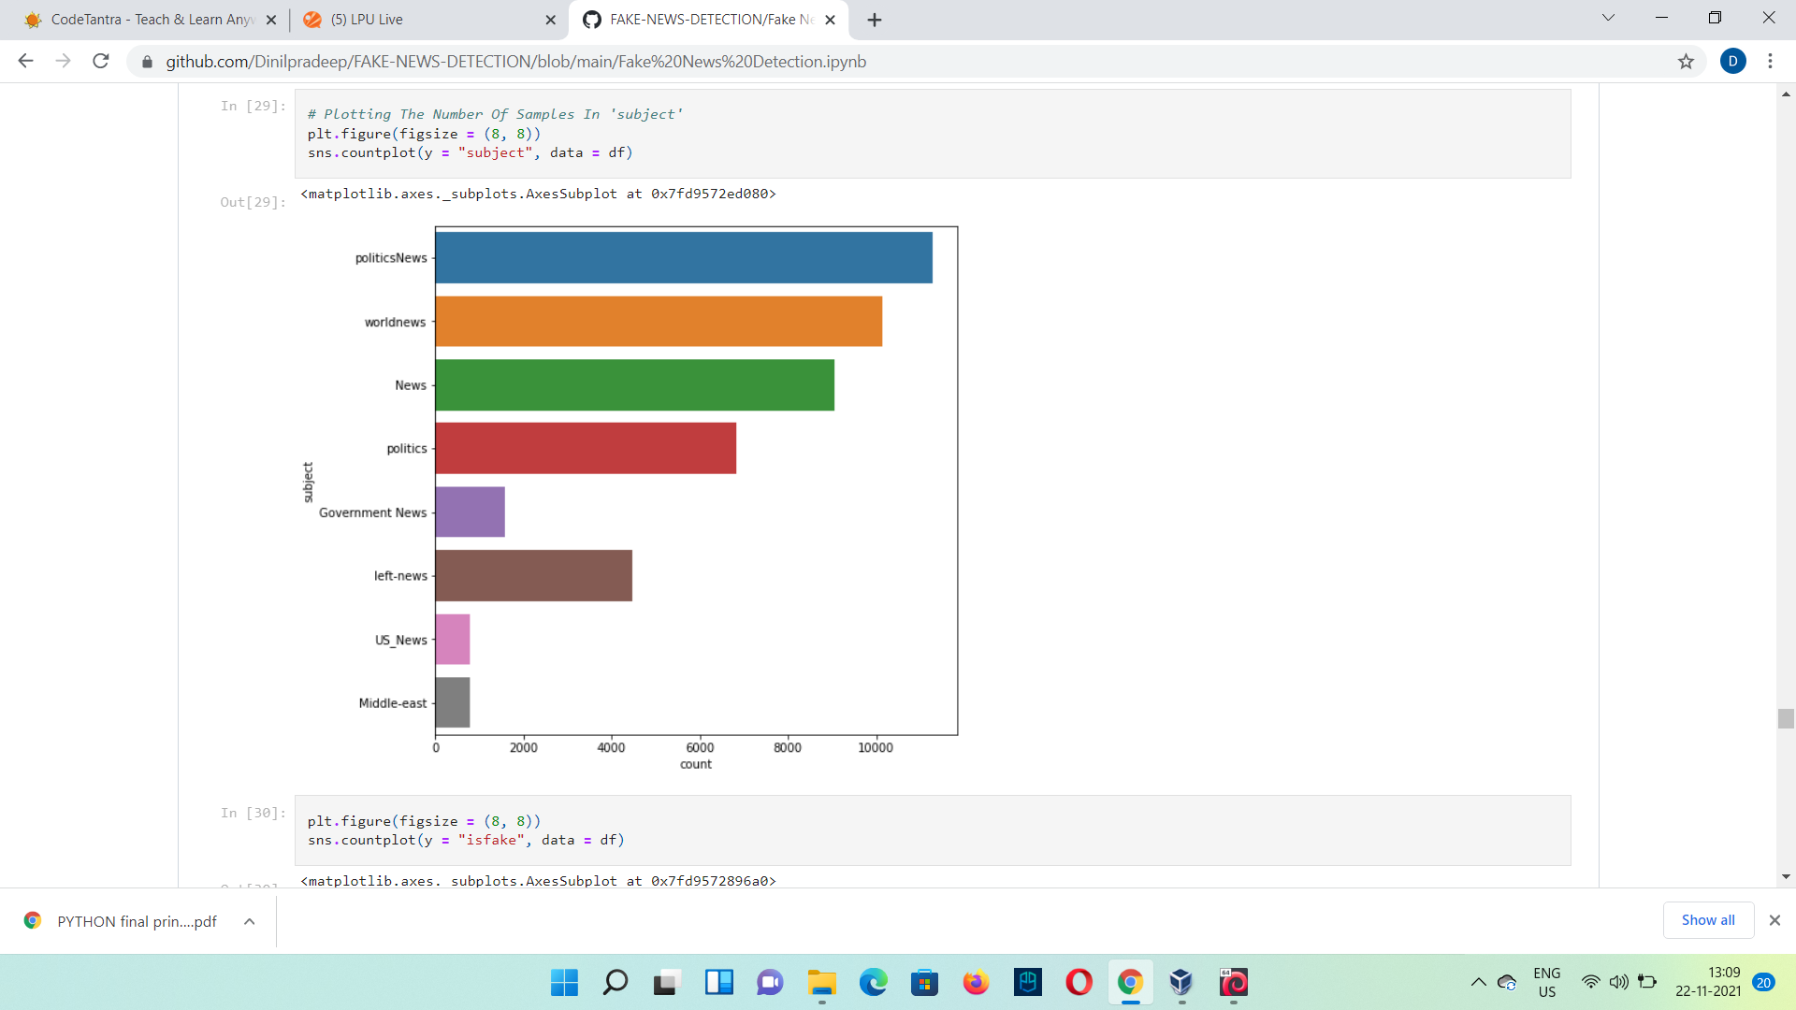

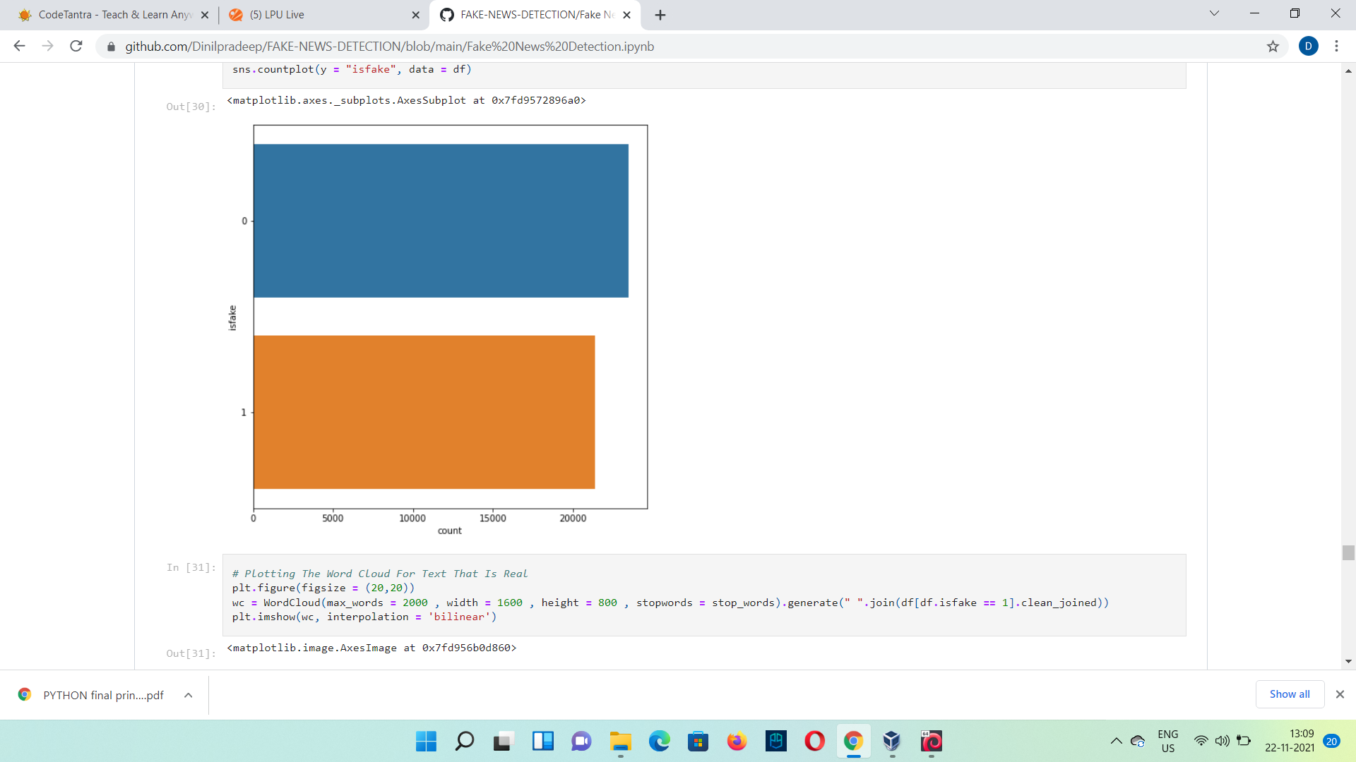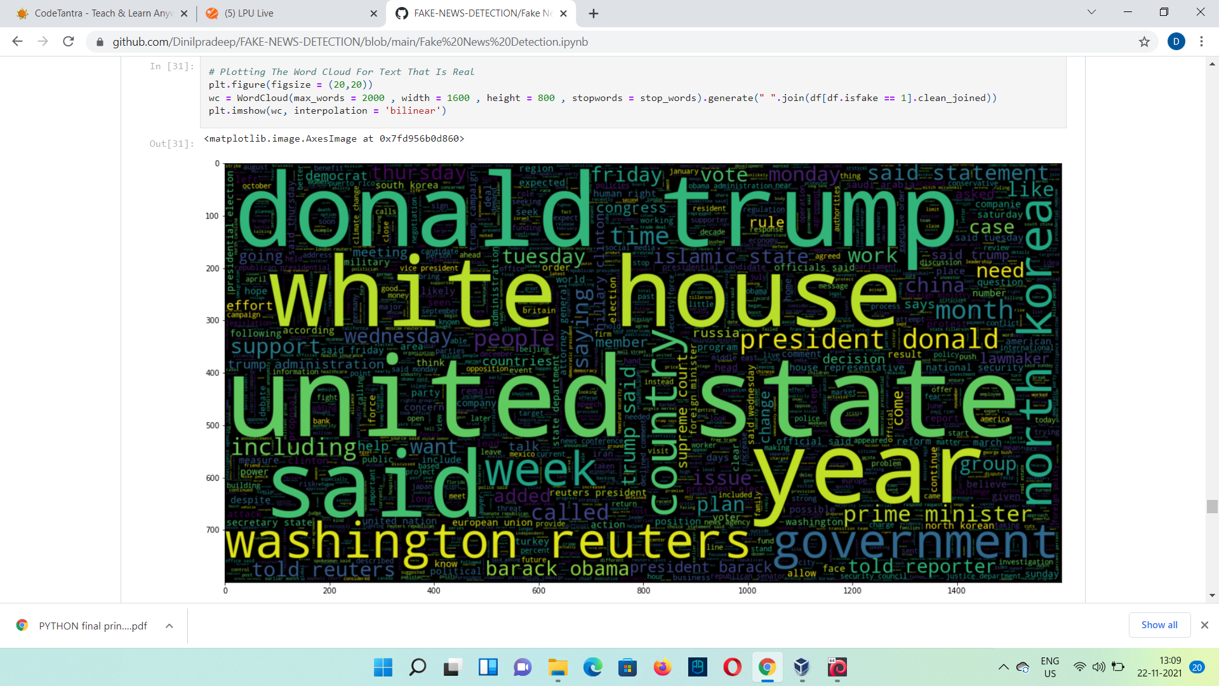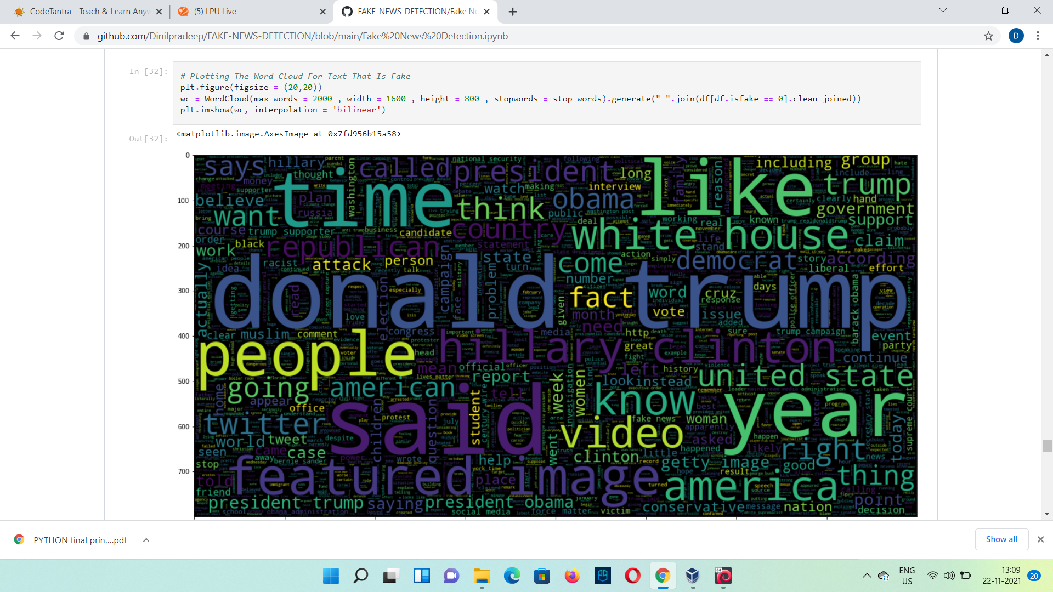

## **REFRENCES:-**

To conduct this project the following tools have been used :

* Jupyter notebook and spyder
* Pandas (Library) : <http://pandas.pydata.org/>
* Numpy (Library) : <http://www.numpy.org/>
  1. **Coursera:-**

We have used this side for our basis knowledge gain of the methods that will be used in the project

[***https://www.coursera.org/learn/machine-learning-with-python***](https://www.coursera.org/learn/machine-learning-with-python)

**1.2 Kaggle:-**

We have used this site for our datasets gathering and asample case project.

[*https://www.kaggle.com/clmentbisaillon/fake-and-real-news-dataset*](https://www.kaggle.com/clmentbisaillon/fake-and-real-news-dataset)